MOCKITO IN EASY WAY

Suppose we have a todobusoness class which calls the todobusinesssservice class.

The todoservice is being developed by some other team and we have interface of todoservice.

So we will create a stub of todoservic impl and stub the methids according to our own use.

**STUB**

A stub is a soample implementation of the real class which we can create in order to use it while the original functionality is not available to us.

**Problem with stub**

The some of the problems with stub are if a new method is introduced in the service interface then we need to provide its implementation also in our stub and hence it becomes a tedious process.

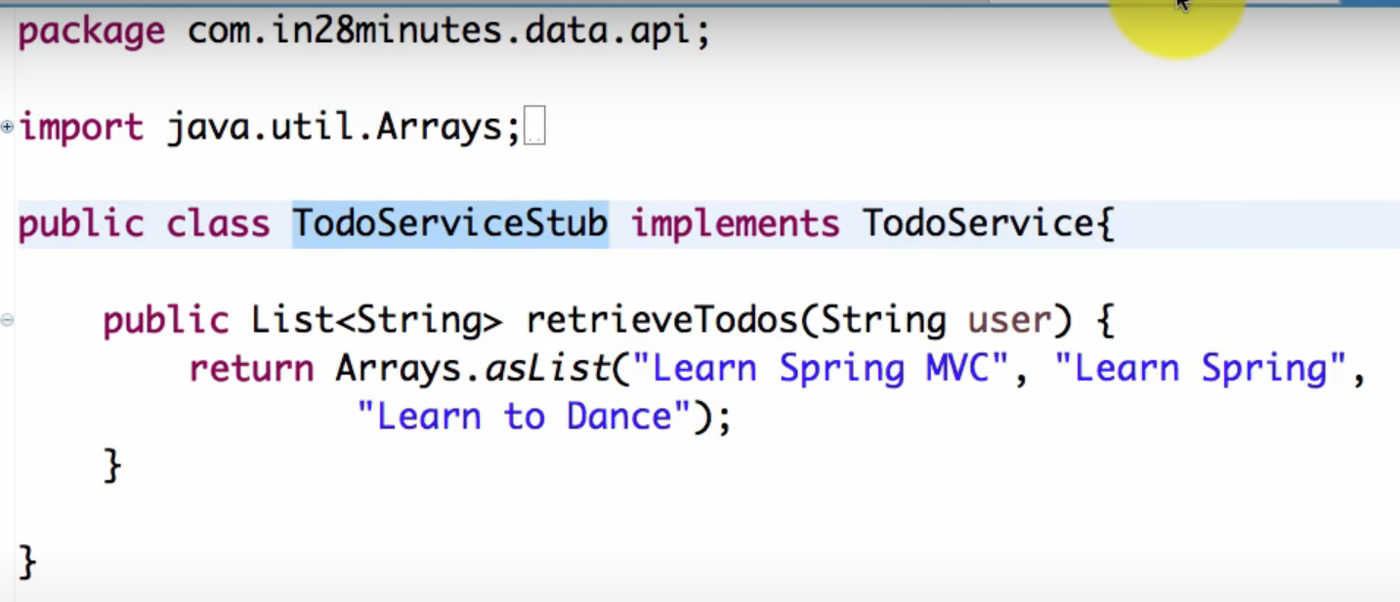



**WHAT IS MOCKING**

Mocking is creating objects that simulate the behaviour of real objects.

Unlike stubs mocks can be dynamically created from code at runtime.

Mock offers more functionality than stubbing

Youc can verify method calls and a lot of other things.

DUMMY

Sometimes in the code under test we have a dependency which generally does not play any role in the code so we need to make its dummy since it does not have business logic implemented.

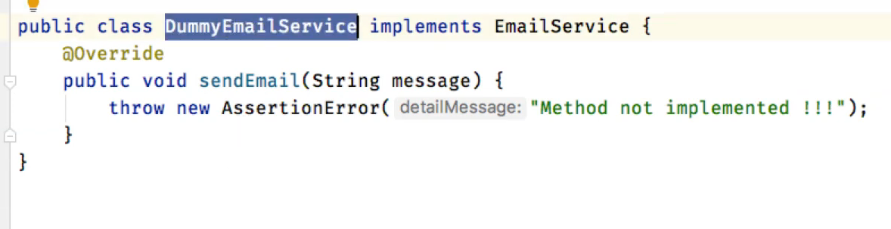

We have an email service which does not hae any use in our code so we will be using its dummy as shown above.

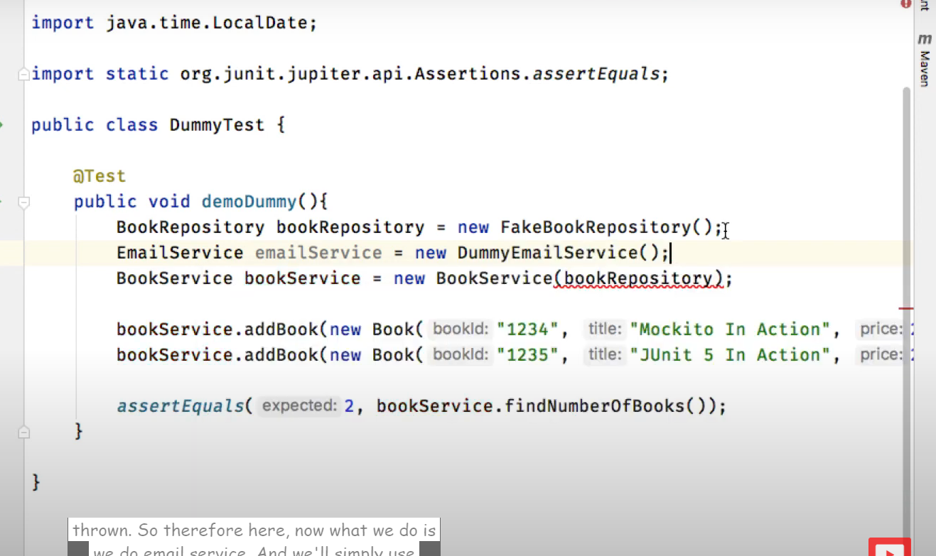

**STUB**

We can use stub in case as shown below

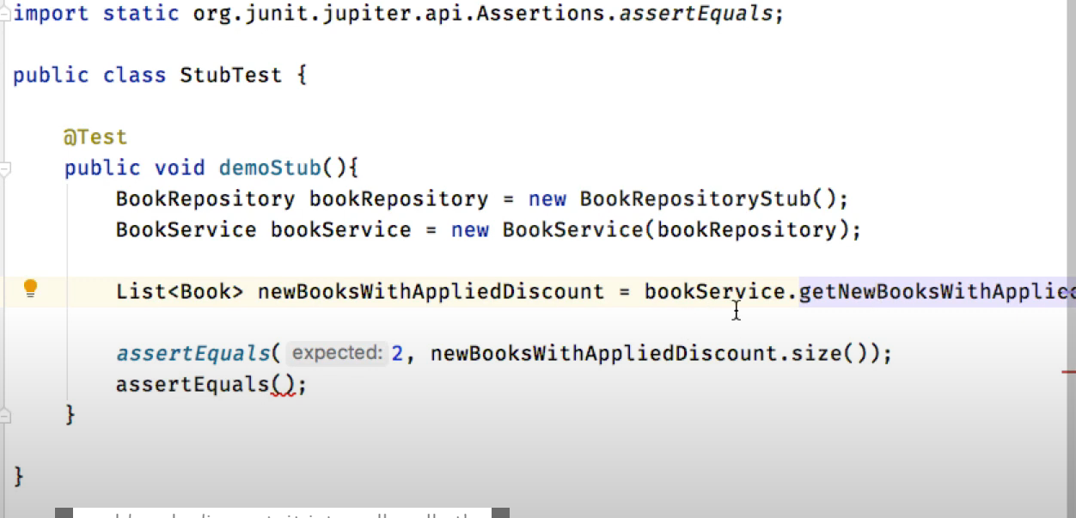

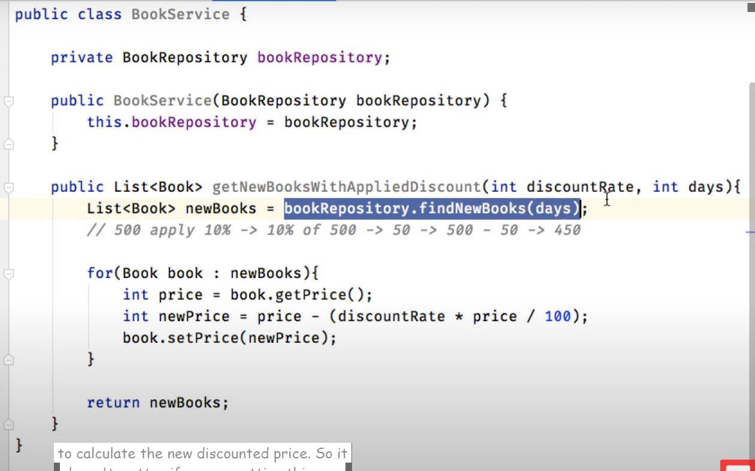

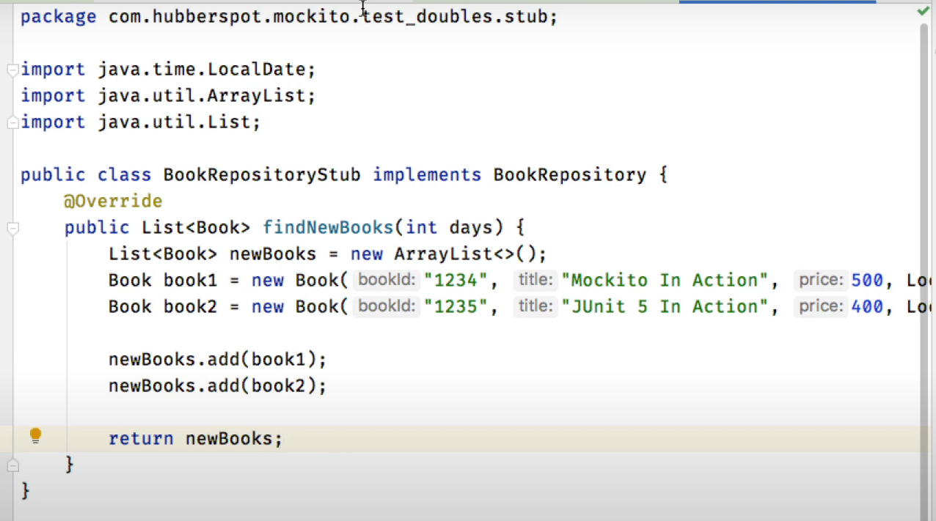

**SPY**

They keep a record on what functionalities are carried out

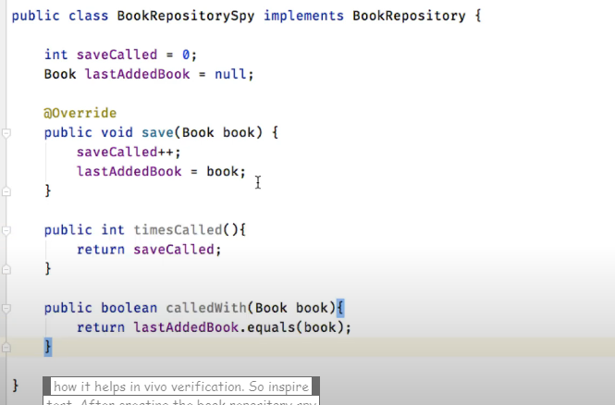

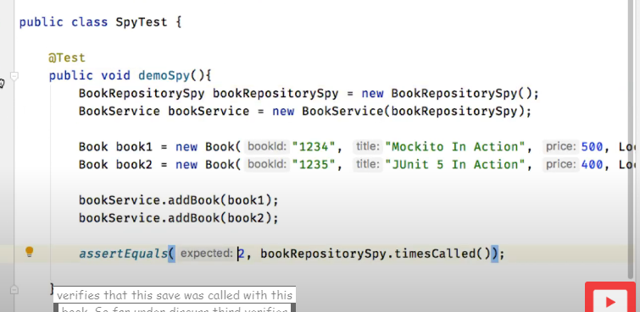

**MOCKING**

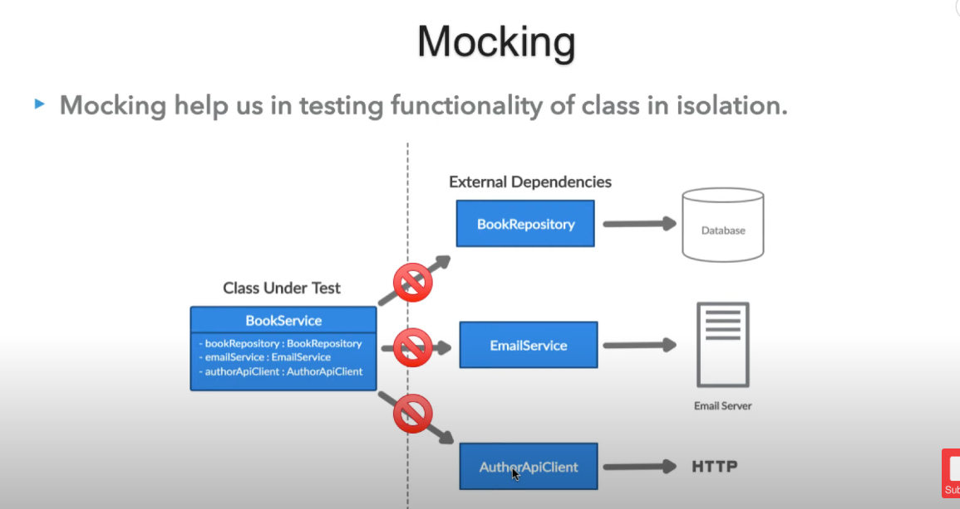

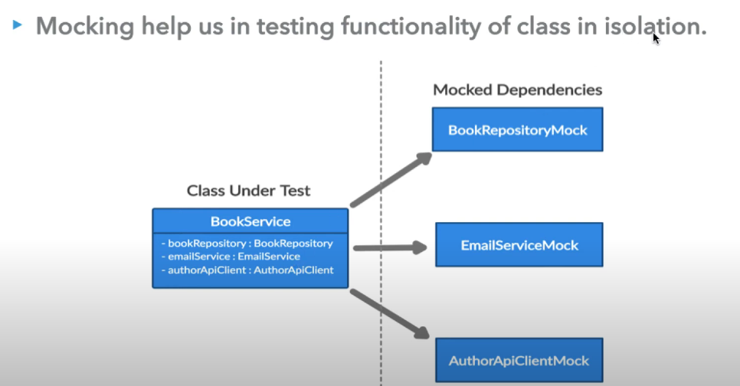

Mocking does not require database connection.coomunicating to external servers or going over network to test functionality

Mock objects simulate real service by taking in actual input and returning bak the expected output.

**INTRODUCTION TO MOCKITO**

Mockiot is an open source testing framework for java

The framework allows the creation of test double objects(mock objects) for unit tests.It uses Java Reflection in order to crate the mock objects

**Benefits of Mockito framework**

* Saves developers from writing test doubles or mock obejts on their own
* It also provide support for exception handling
* It has support for stubbing methods.It help us in returning configured response
* It can check orderof method calls and number of times method is being called.
* Annotation support

**MAKING OF A FAKE CLASS**

Suppose our service class is depending on the repository class do get and save the books so manually if we do we will make a fake repo and store the book info in a hashmap as can be seen below:

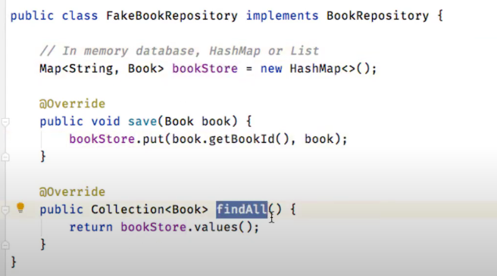

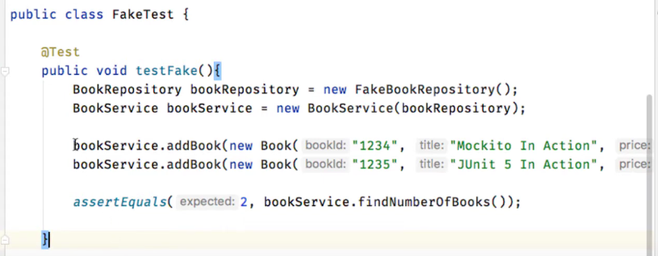

So above we will write the test case and pass the fakebook repository as an object to it .

**Using Mockito**

Mockito will give us a mock of the repository class which will help us perform our operation

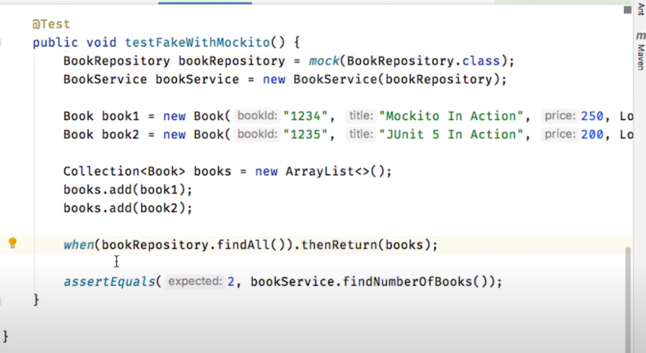

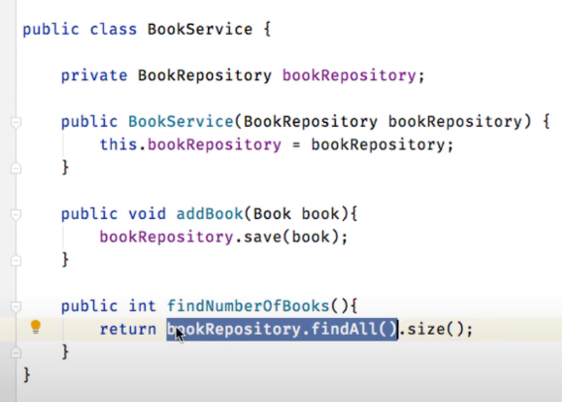

Above we have created a mock of the bookrepository and also provided that when some method is called on that mock then what action needs to be taken

As you can see in above service class when book repository.findnoofbooks is called then no call is made to the repository but our mock object will return us.

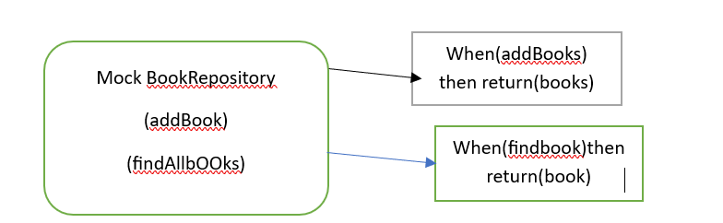

**DUMMY TEST DOUBLE**

A dummy is used in case there is some other dependency in the class we are testing but it has nothing to do with the functionality that we are testing so we will make use of a dummy test double

Suppose in our service class there is a dependency of Emailservice so in our test we will make a dummy of email and then pass it to service.Bookservice object can only be made if email service is passed so we will mock email service.

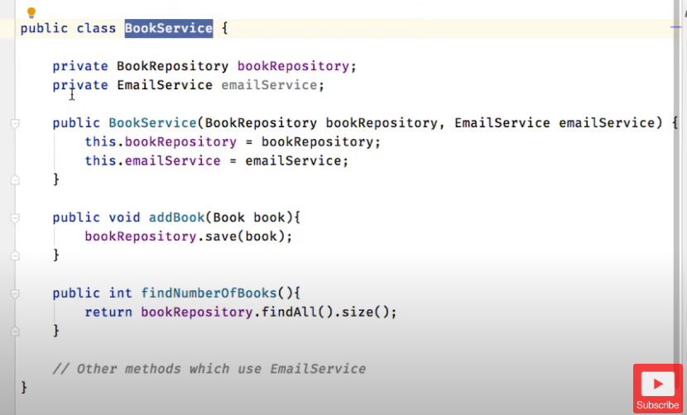

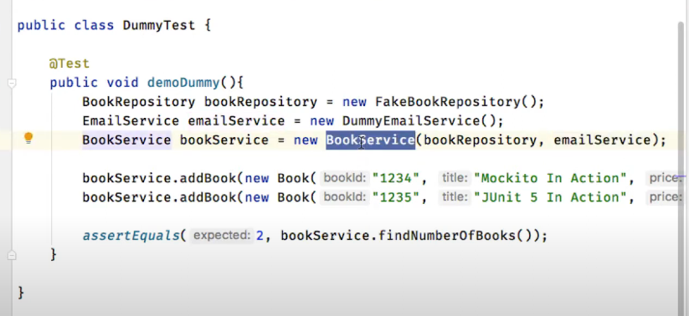

Now compile rris happy that it has the email method

**USING MOCKITO**

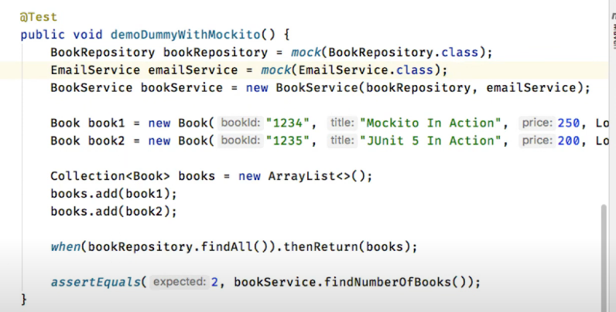

**STUB TEST DOUBLE**

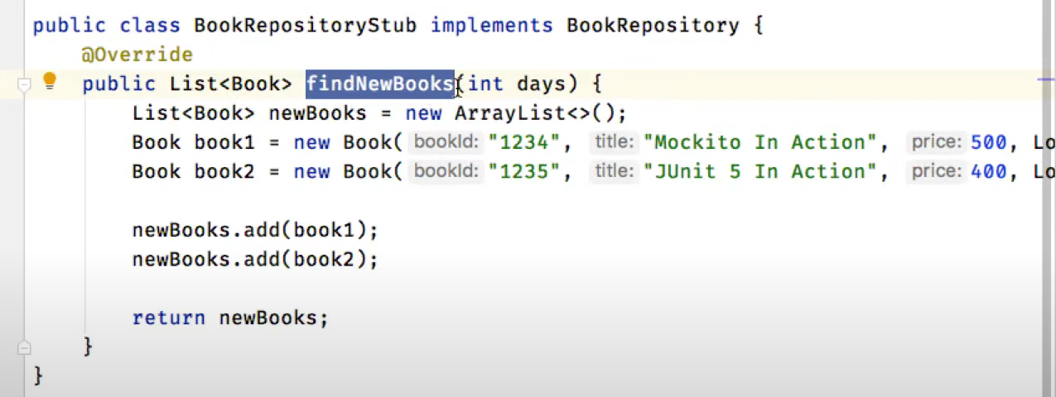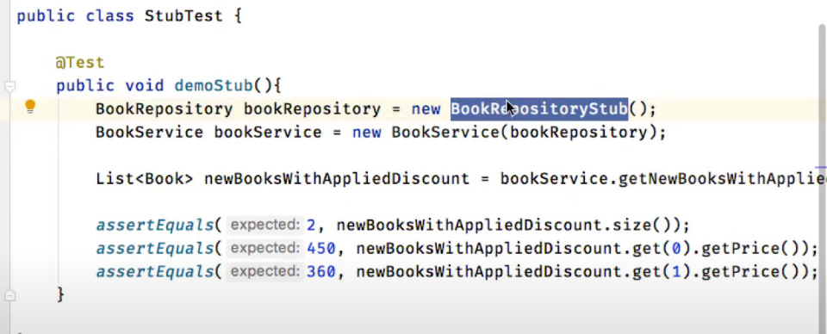

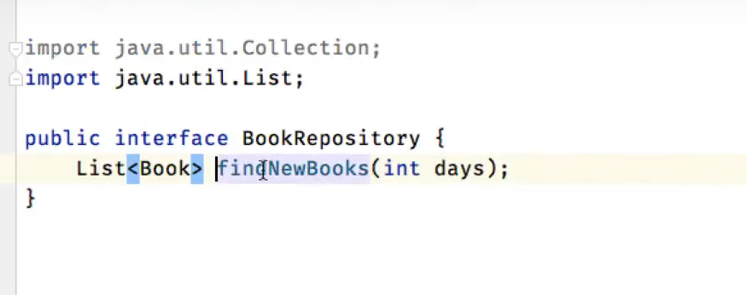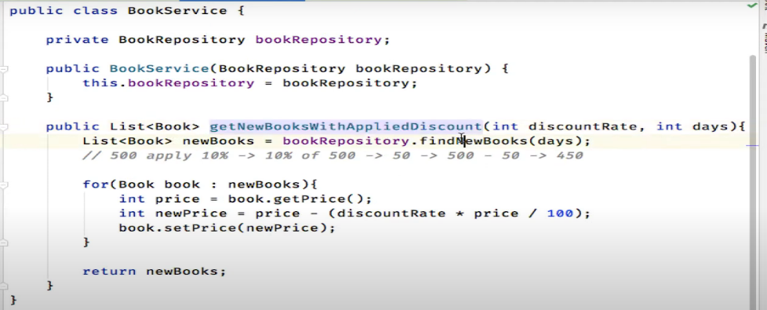

**In the above**  example we had a service class which calls the book repo.now we wanted to test the getnewbookswithapplied discount method .we basically wanted to check if the prices are retrurnig correctly ornot or if the discount functionality is working as expected or not

So we made a bookRepoStub and in that class we added some books and then form the test we called the service method by passing object of the bookrepostub and verififed the results of answers calculation

**MOCKITO**

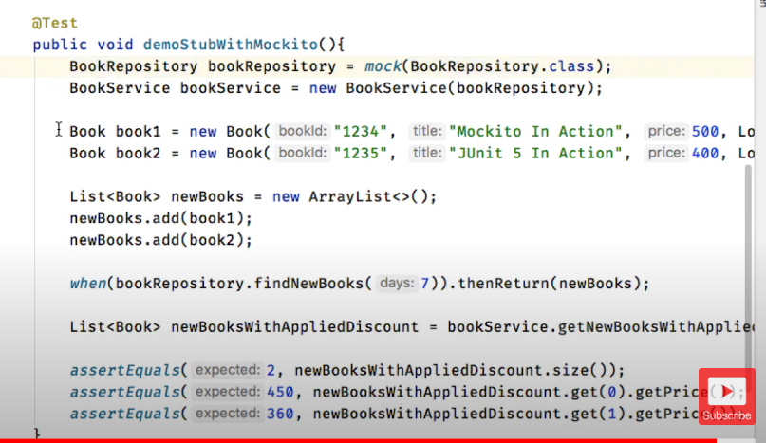

**MOCK TEST DOUBLE**

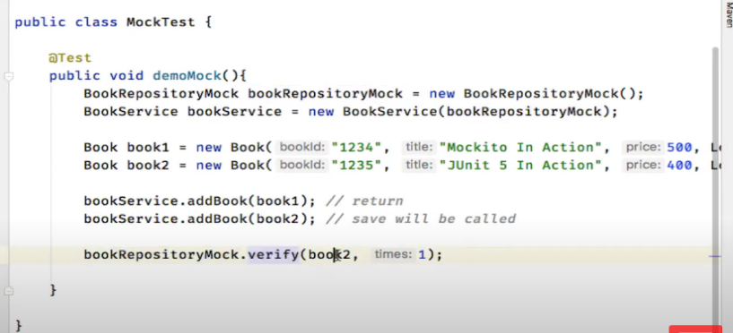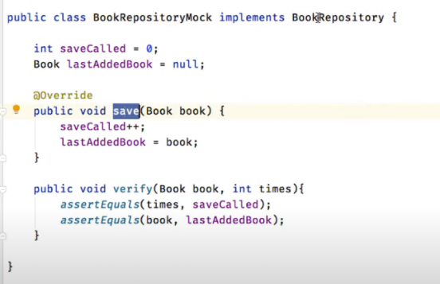

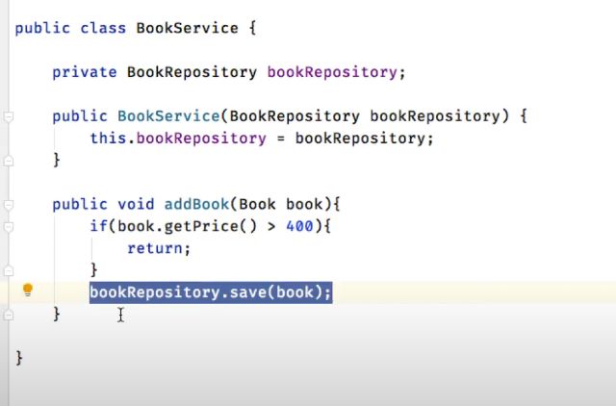

In the example it can be seen that we need to check how many times a method was called so e made a bookrepo mock and passed it from the service andwhen bookservcie.add was called then if bookprice was>400 then repository method was called and hence we could verify how many time this method was called

**USING MOCKITO**

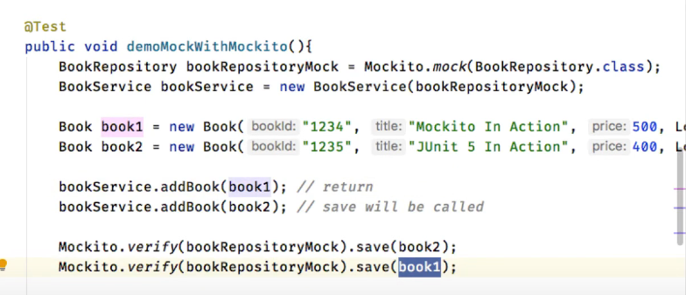 **Here**  it is verified that save of service was called only for book1 but not for book2

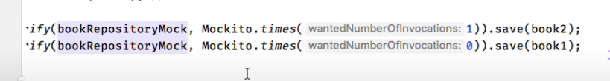

**SPY**

Both mock and spy are used for behaviour verification but the only diff in mock and spy istaht mock does the behaviour verfification at mock end as it was done in the bookrepomock where we did a count++ but if we talk about spy the behaviour verfification is done at the test level only

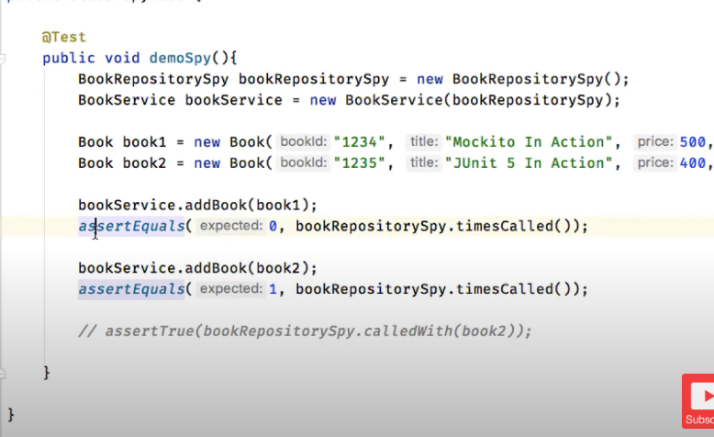

**SPY USING MOCKITO**

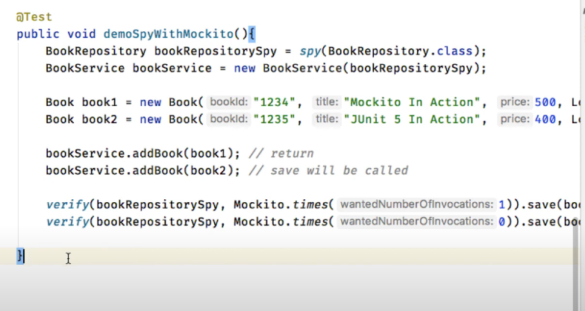

**CREATING MOCKS USING ANNOTATIONS**

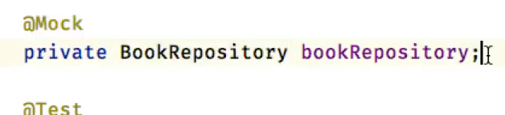**we** can create a mock using @Mock annotation but our system will not now what to do with hem

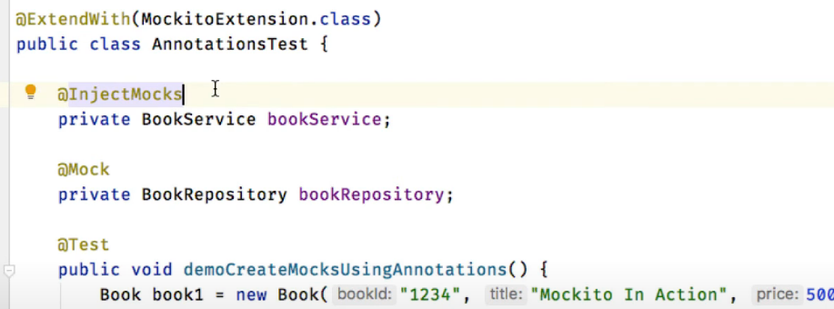**@Extend with:** It will tell our class to extedn the mockitoExtension and use the variables marked with @Mock

**@Mock:** these are the dependencies on which are class under test is dependent.(Service(inject) has repository autowired so BookRepsotiry is mock

**@InjectMocks:These are**  the classes in which mocks will be autowired.

@RUN**WITH**

This is the old way of doing thigs

If we are using th ejunit4 we will be giving the @runwith instead of mockitoextension

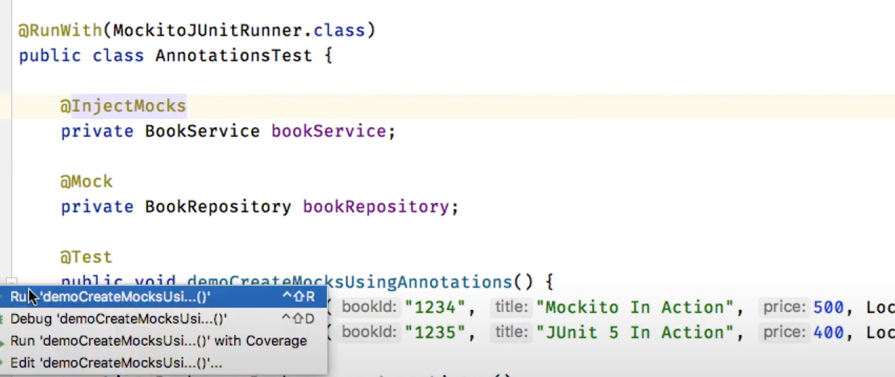

**MOCKITO.init**

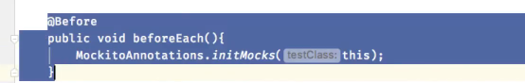

Will make mocks without any annotation.is used with Mockito jrunner class.is usec to create a instance of class in which we are writing code.

**USING MOCKITO RULE**

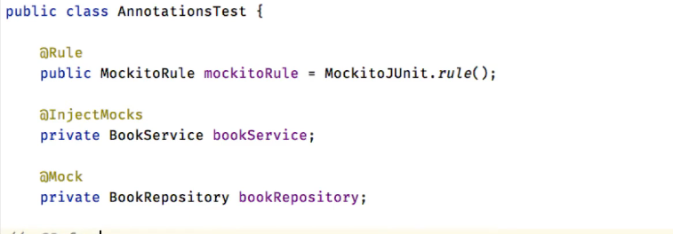

Just another way of initializing the mocks.

Imp to mention it as public

**WHAT IS STUBBING**

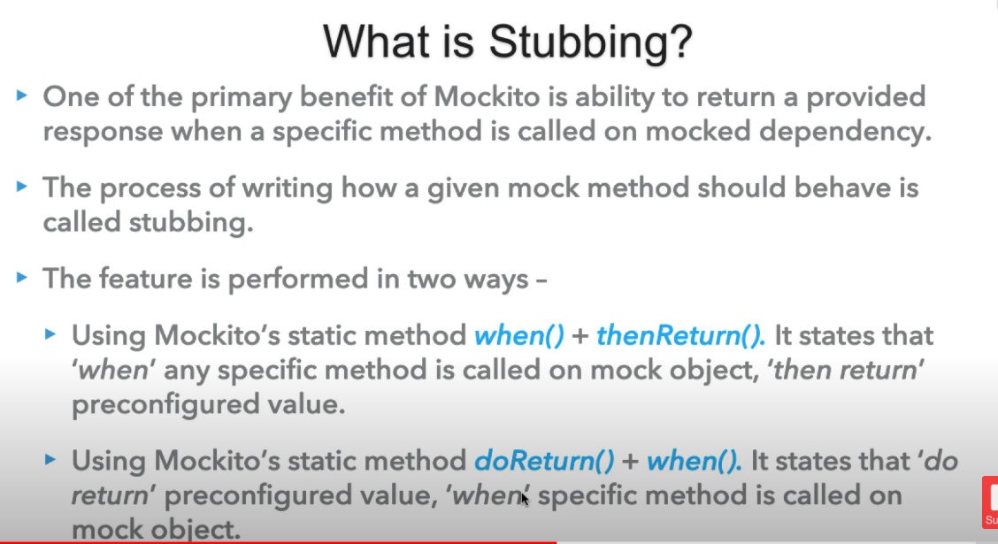

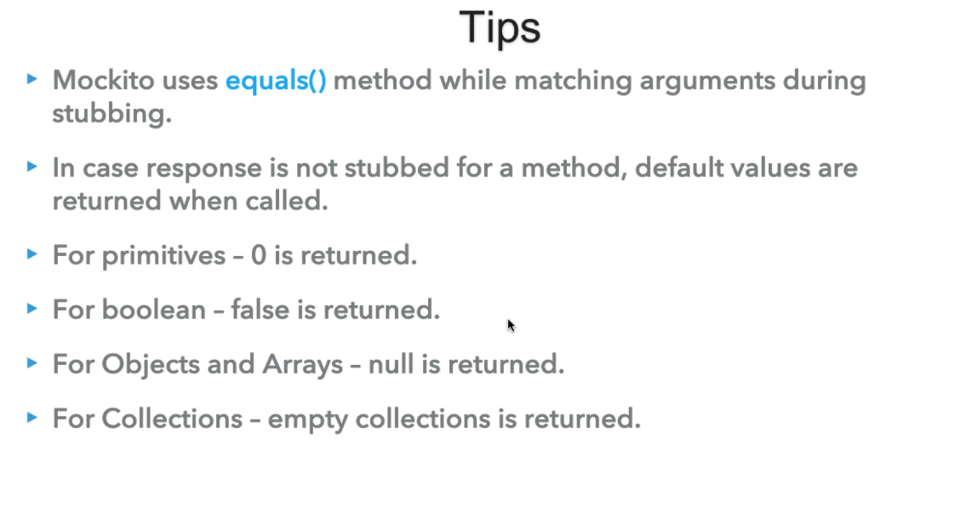

**EXAMPLE**

We have a service class with the method as shown

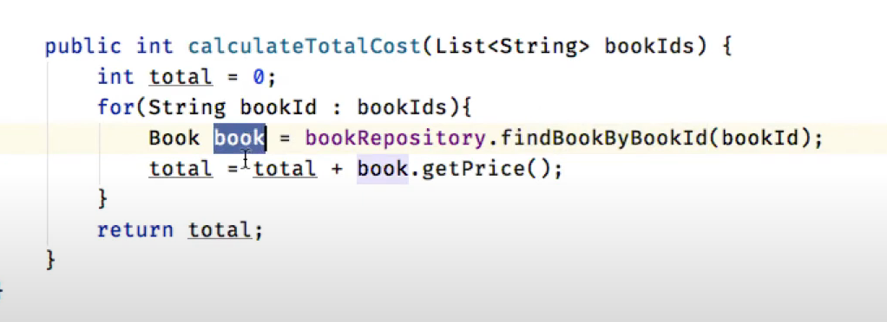

We will write a test case for this as shown

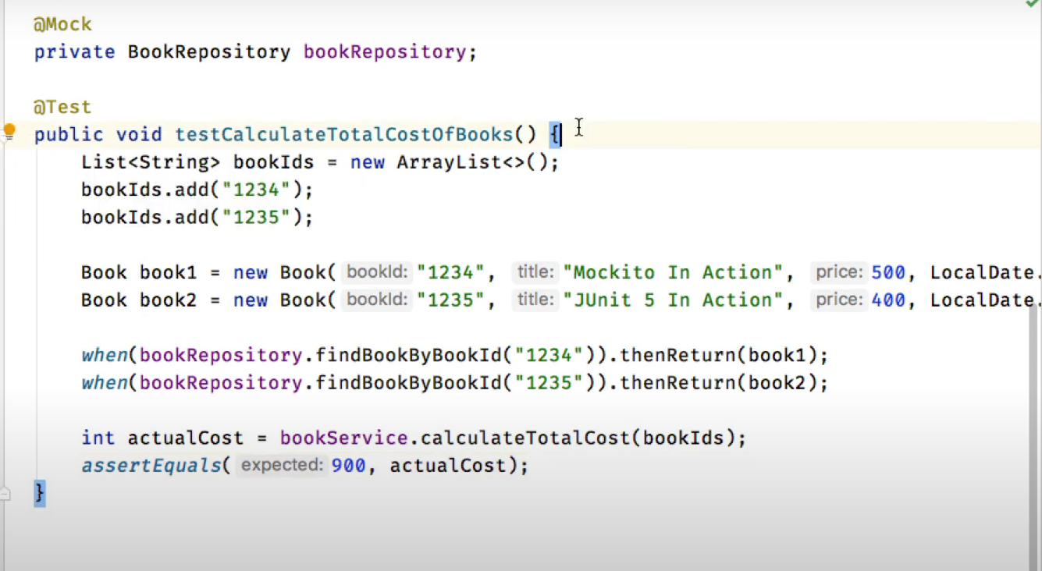

**Doreturn().when()**



**Chaining**

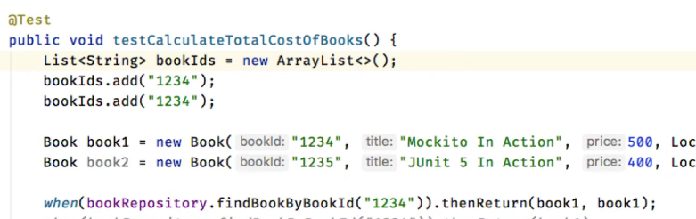

**Or**

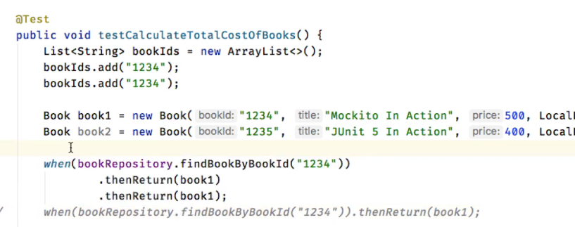

Suppose bookrepo.findbyid(“1234”)

Is called two times then first time book1 returned and on next call book2 returned

**Void method(doNothing())**

We cant use when and then in that case

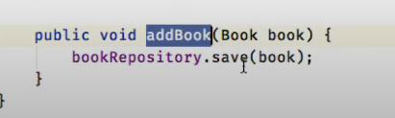

Since it does not return anything to us in return

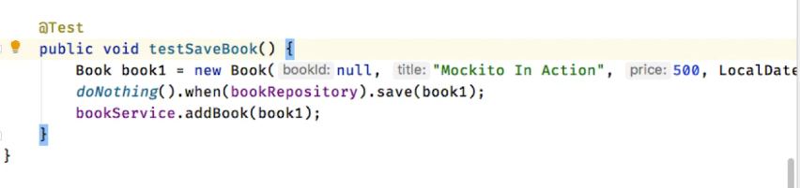

**Potential Stubbing exception**

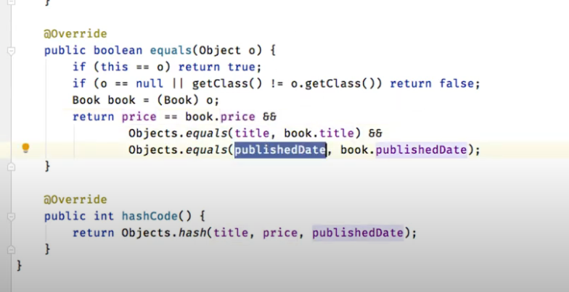

**BEHAVIOUR VERFIFICATION**

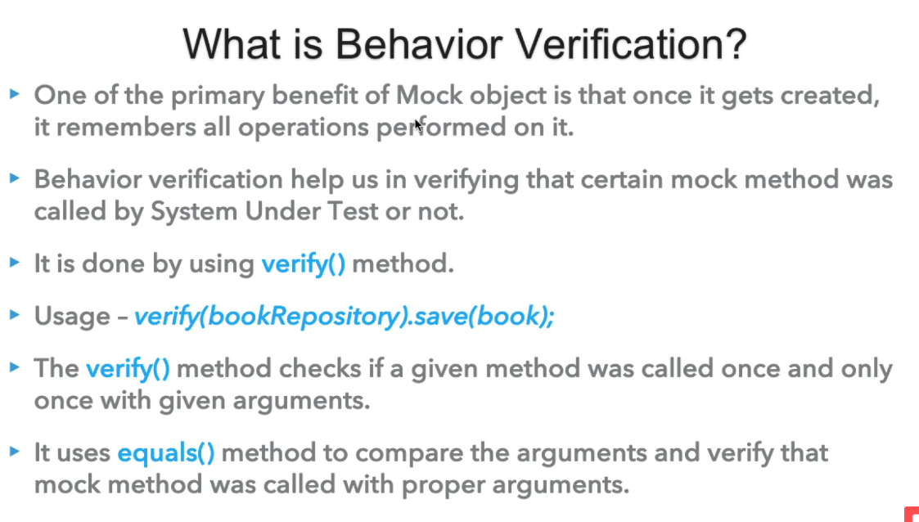

**DEMO OF VERIFY METHOD**

We have a book service and a book repo interface

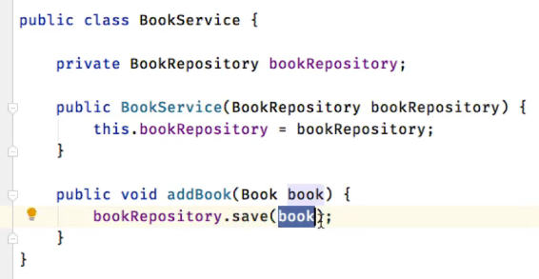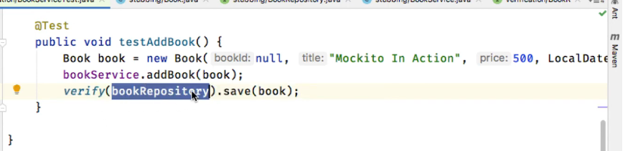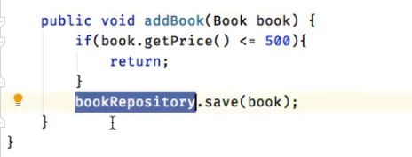

**In**  the above example we have a service class and in that service we have a addBook method which internally calls the save of bookrepository

Now w e ant to verigy if the bokrepo method was called or not

So we do verification

**BEHAVIOUR VERIFICATION OF A METHOD**

We need to check whether a particular code part was used or not

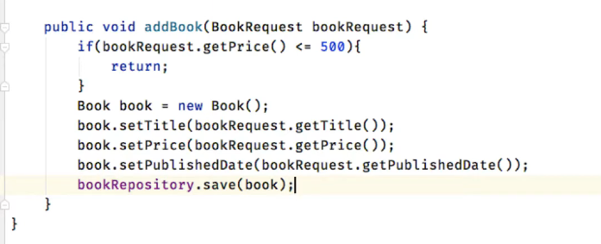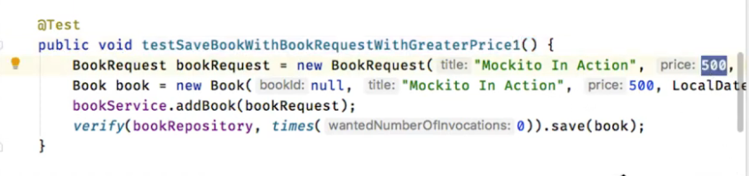

Suppose as shown above we have a method addBok and it only saves in repo if the book price

<500 else it returns so we need to test from where was the call returned.

So we write the test case and methionthe time smethod to know whether the method was called or not

Here we need to mention that the method should not be called so we mention 0 times

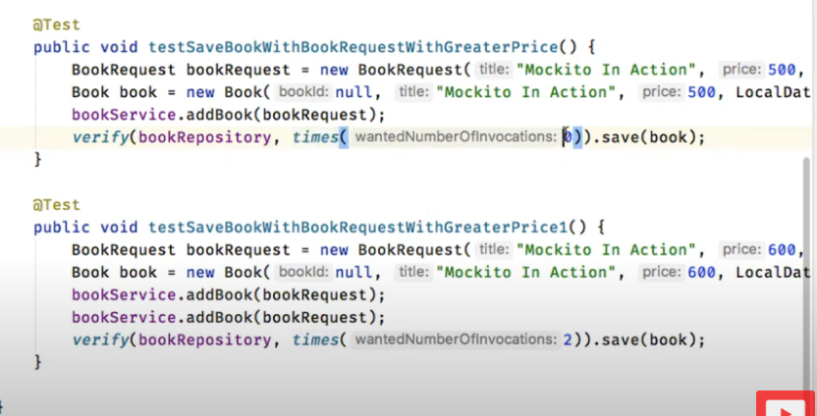

**REPLACEMTN OF TIMES**

If we want to test if a method should not be called

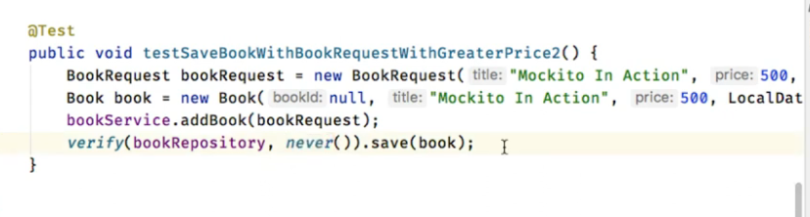

We can verify that save was never called on the mock object

**VERIFY NO INTERACTION WITH MOCK**

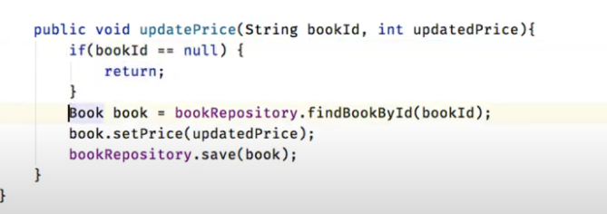 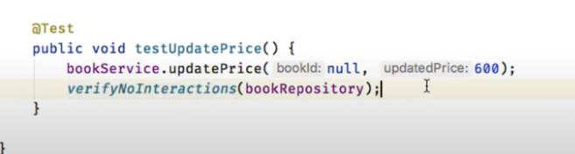

In the above example we have amethod update Price in the servcei class and then if the bookId is null which is passed to it then no interactio will be made with the databse so we have tested ffo this method in the class

**VERFIFY THERE ARE NO UNEXPECTED INTERACTION**

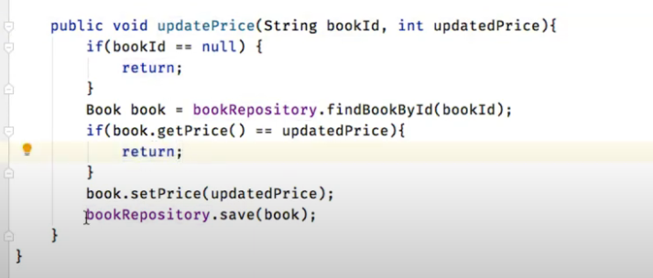 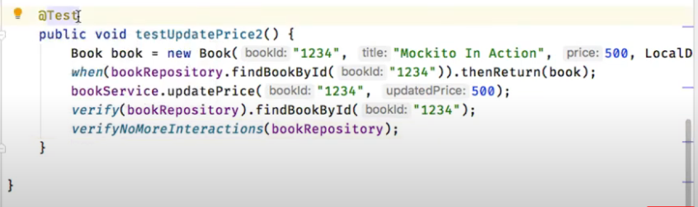

**In** the above we have a updatePrice method which will make two calls to the repository.

Here we want to verify that after only one interaction there are no more interacations

So we use the above test to do so.

It will check that after doing the findbookbyid there are no further interactiosn with the bookrepository

**VERFIFY ORDER OF EXECUTION OF METHOD CALL**

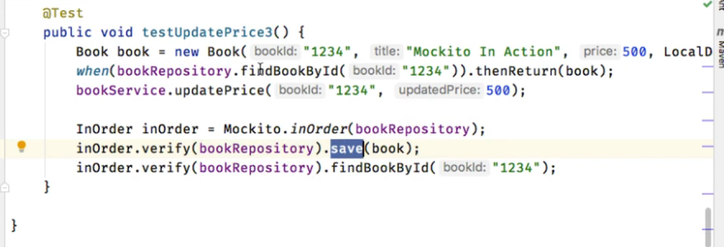

**VERIFY AN INTERACTION OCCURRED CERTAIN NUMBER OF TIMES**

We can check for atleast and atmost number of times a an interaction was done

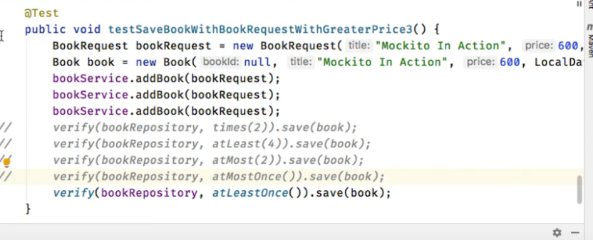

**EXCEPTION HANDLING**

We need to cover our negative scenarios

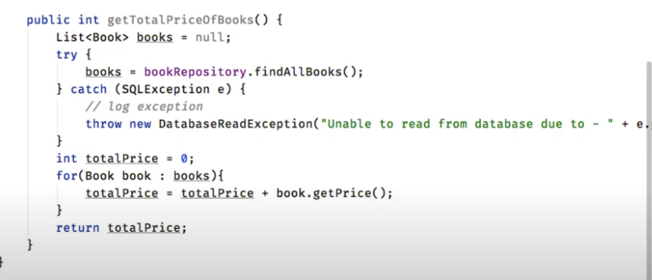

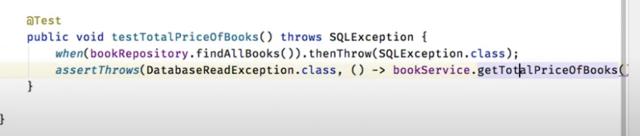

**EXCEPTION HANDLING ON VOID METHODS**

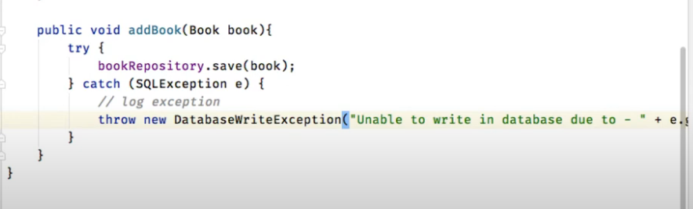 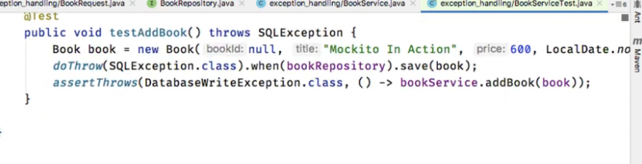

**ARGUMENT CAPTORS**

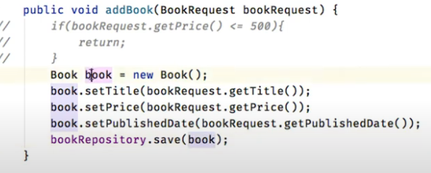

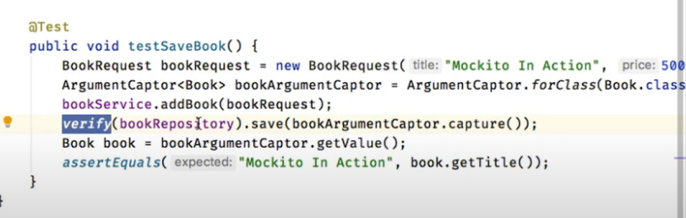

Here in the above example we have a addBook method in the seervcie class

Now in this a book object is created so we want our Mockito to capture that object and perform assert on it in the etst

Here in test **bookArgumentCaptor**  will have the book

Then we verify if with this argumentcaptored book save was called

Then we take its value out and verfifies

**ARGUMENT CAPTOR USING ANNOTATIONS**

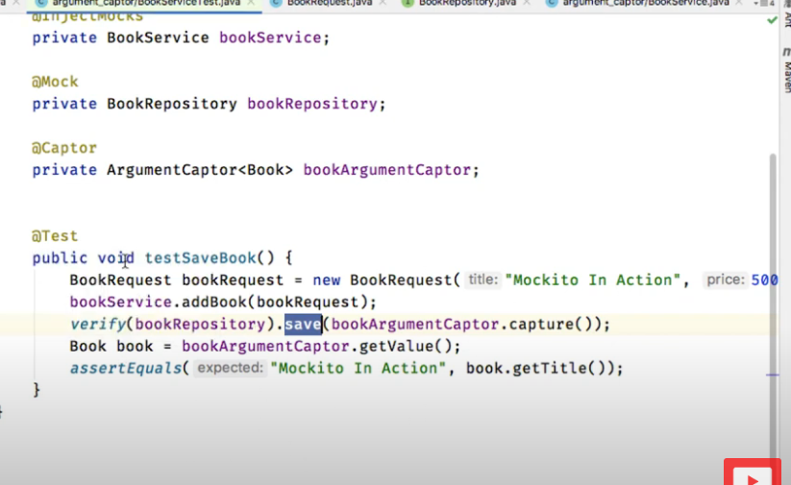

**SPY IN MOCKITO**

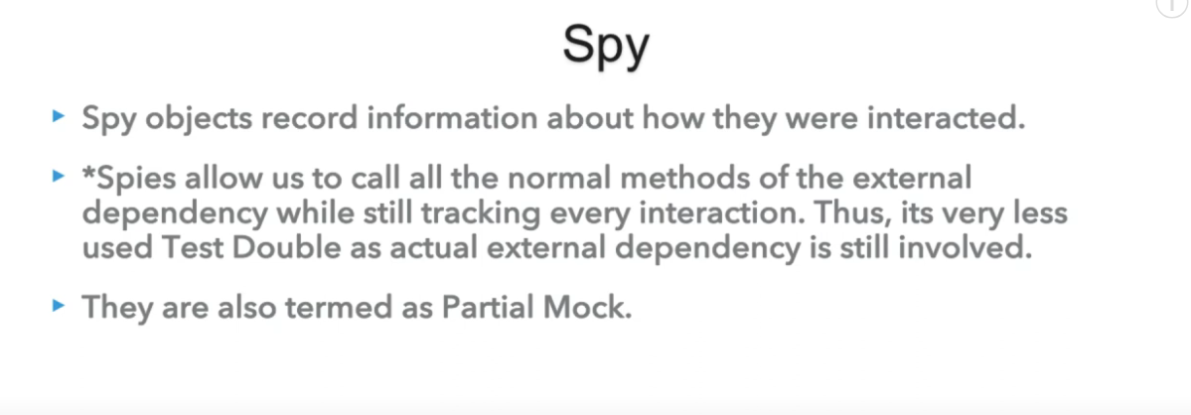

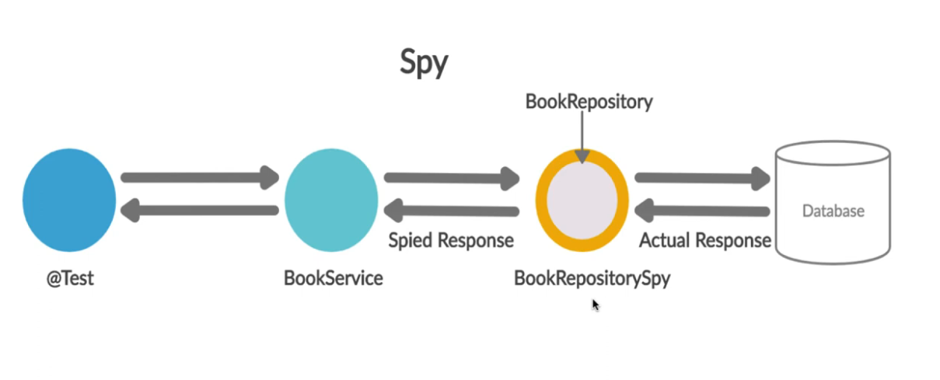

**SPY USING MOCKITO**

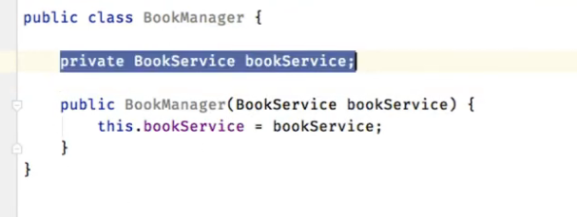 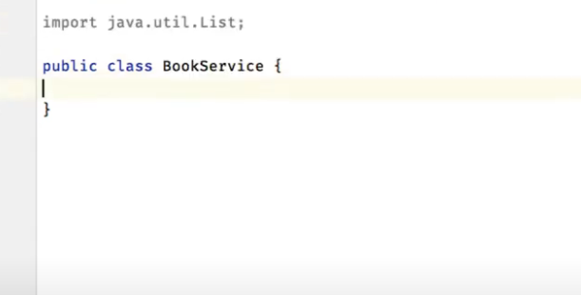

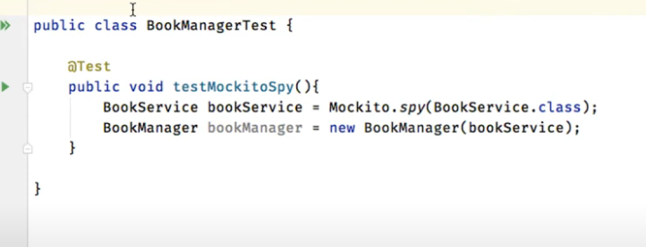**another way of making spies**

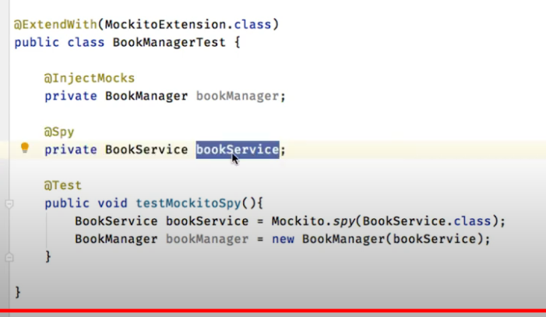

**USING A SPY**

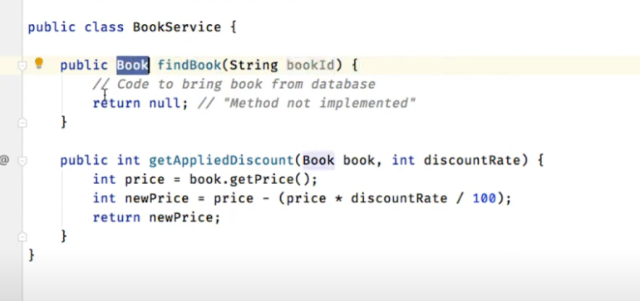 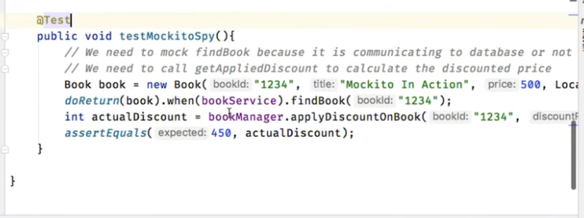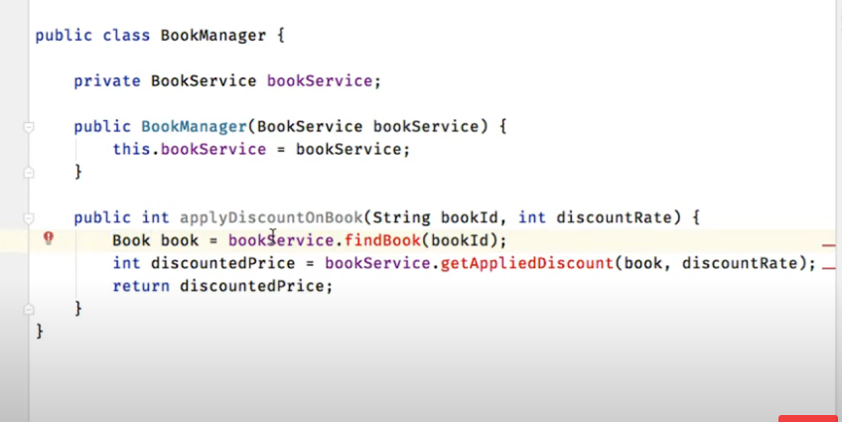

* We have a service class which has 2 methods one in implemented an the other is not implemented
* We created a spy of book service since it has partial implementation
* We want to test the applyDiscount method of manager
* Now when bookservcie.find book is called a mock book is returen
* And getAppliedDiscount is actually implemented
* Thus it is the advantage of a spy that it help us in doing partial mocking

**BEHAVIUOR DRIVEN DEVELOPMENT**

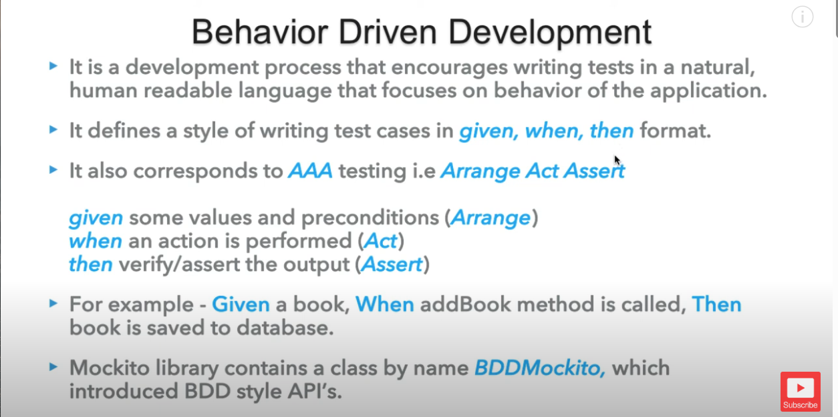

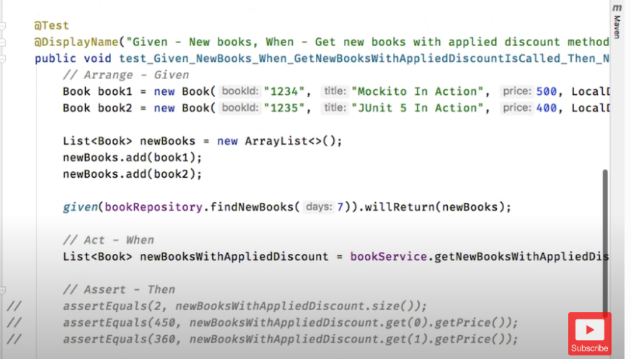

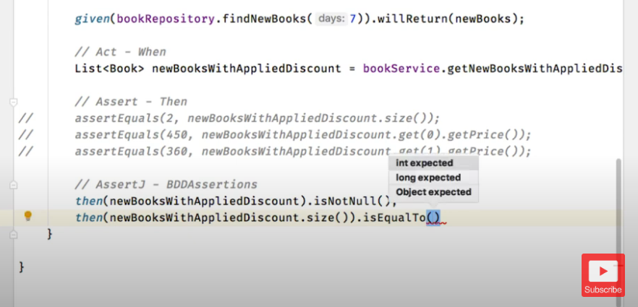

**BehaVIOUR VERIFICATION USING BDD**

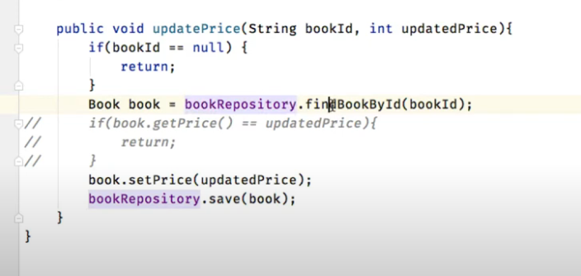

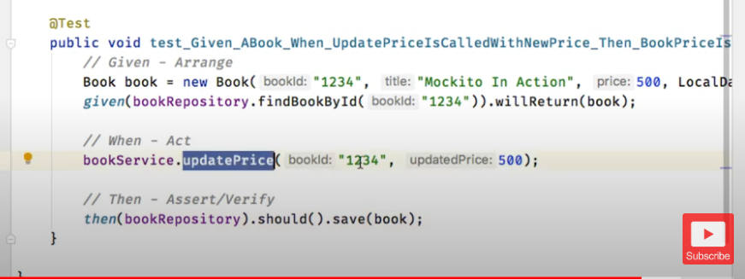

**EXCEPTION HANDLING IN BDD**

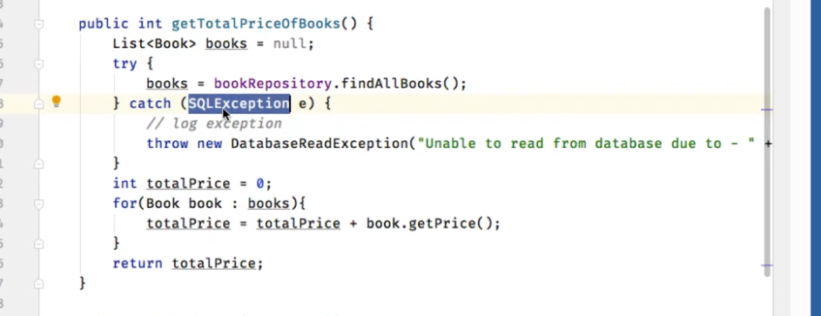

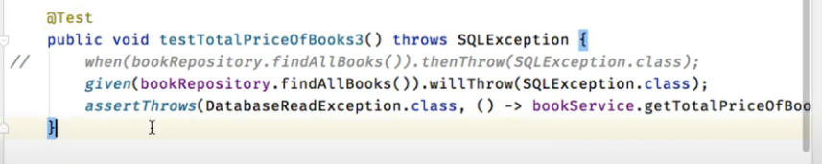

**ARGUMENT MATCHERS**

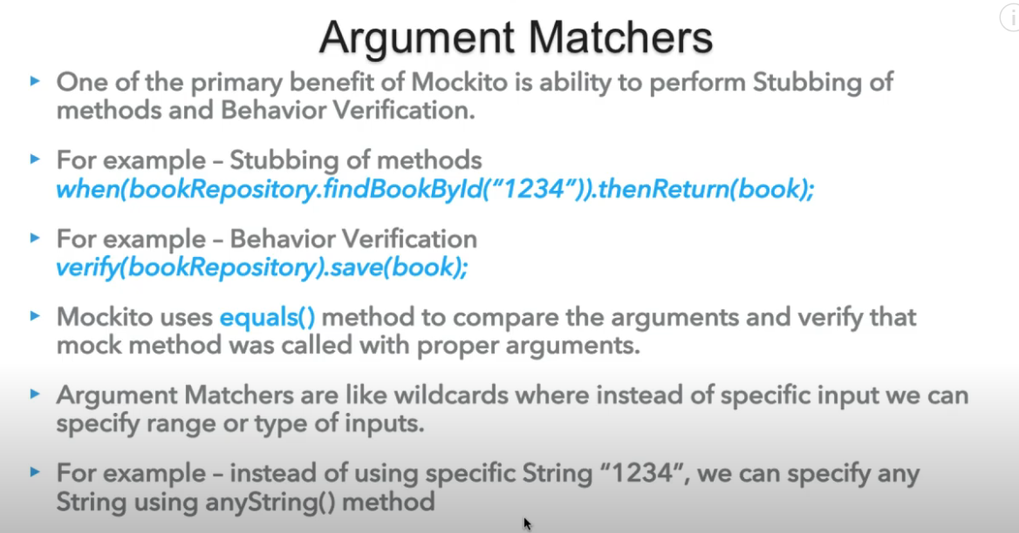

**TYPE ARGUMENT MATCHERS**

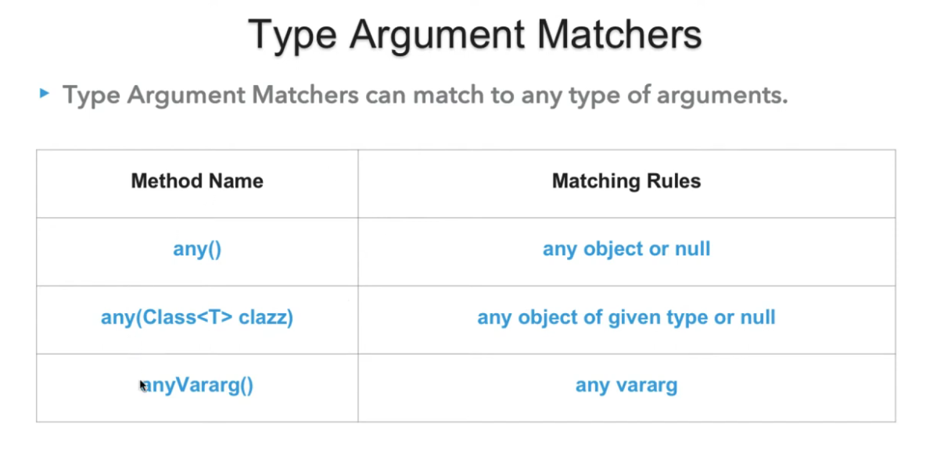

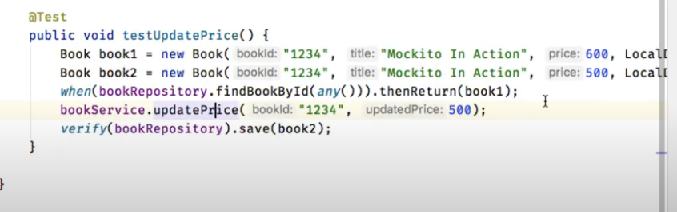

**INVALID USE OF ARGUMENT MATCHERS**

FAKE

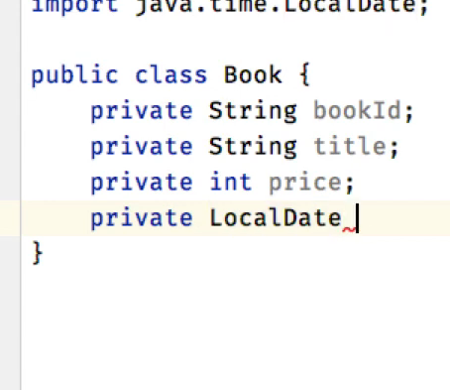

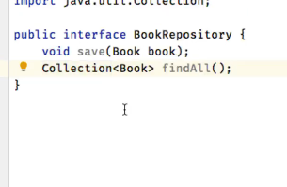

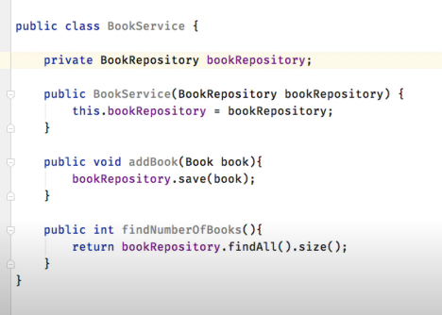

Test acse

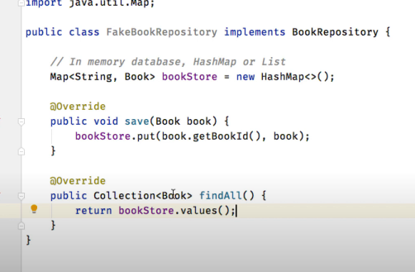

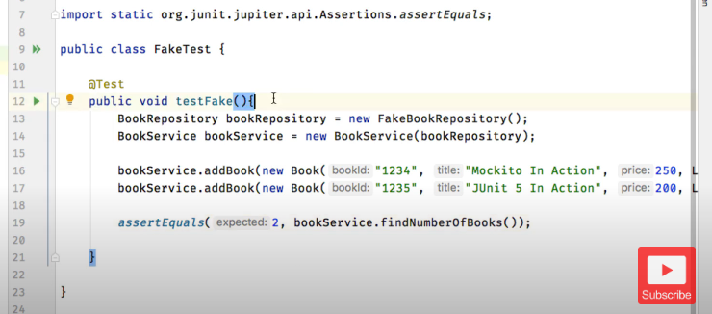

**DUMMY**

We will be using the above classes only

Book,bookrepo,bookservice

But now we have a new dependency of email but we don’t want to use it so we will make a dummy of it

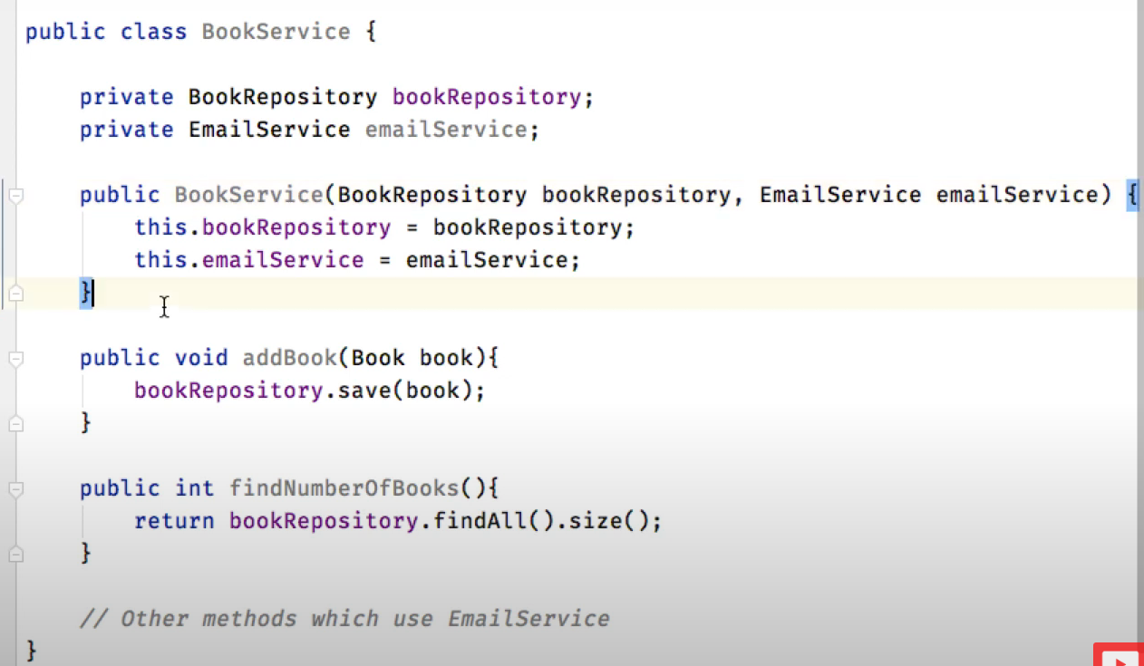

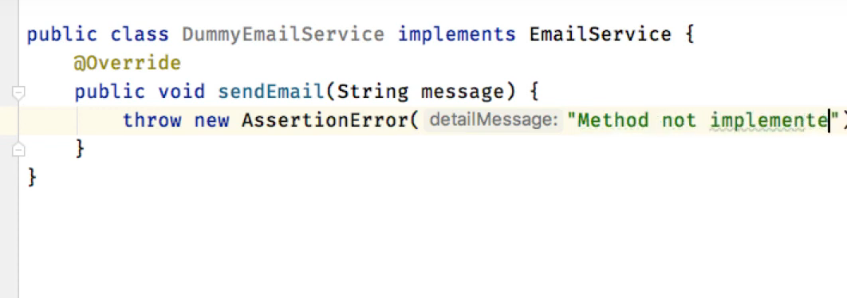

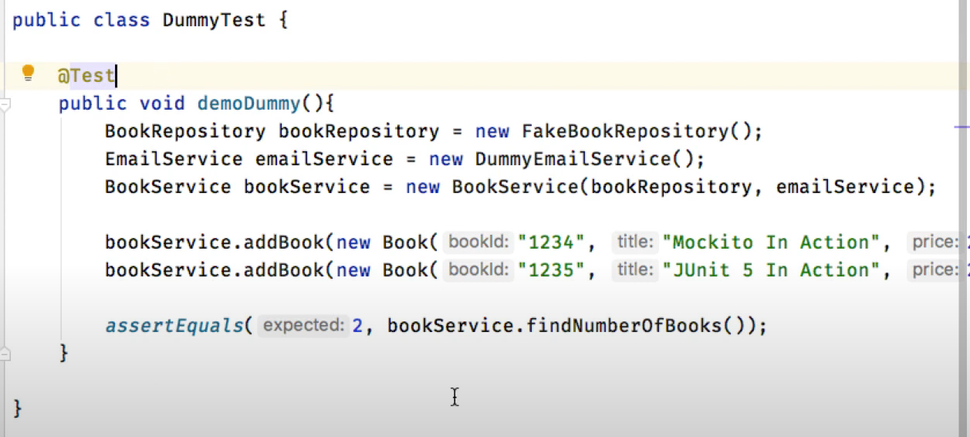

**STUB**

